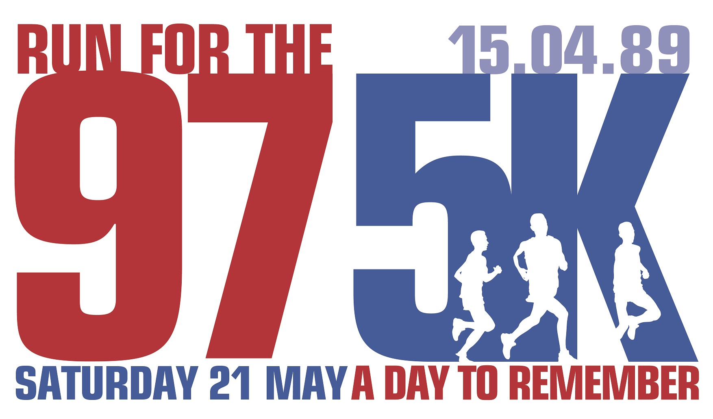
FOR IMMEDIATE RELEASE:
Sunday 29 May 2022

POIGNANT EVENT RETURNS TO STANLEY PARK AFTER THREE YEARS AS RUNNERS UNITE TO REMEMBER THE 97

Over 1,000 turn out for eighth annual Run For The 97

Runners stand side by side in Stanley Park for football anthems

The eighth annual Run For The 97 5K returned to Stanley Park last weekend for what was a poignant, emotional, and uplifting event (Saturday 21 May).

Just over 1,000 participants donned specially designed yellow T-shirts carrying the number 97 as they walked, jogged and run to remember The 97, completing either a 5K fun run or 1 Mile for youngsters.

The event was last staged in 2019 due to the pandemic, so all involved were delighted to once again come together.

Official charities for the 2022 event are Jamie Carragher’s 23 Foundation, LFC Foundation, Everton in the Community, and Stanley Park junior parkrun – all support the vision of creating a legacy to honour The 97 while ensuring local communities benefit through their work.

First staged in 2015, the community legacy event was created to celebrate and honour the lives of the then 96 Liverpool Football Club fans lost in the Hillsborough tragedy. It also remembers the families and survivors, who have since tirelessly fought for justice with the utmost dignity.

Run For The 97 now also honours Liverpool FC fan Andrew Devine, who sadly passed away in July 2021. Andrew received life-changing injuries at Hillsborough, he died 32 years after the disaster.

Special guests included former Liverpool Football Club players Jamie Carragher, David Fairclough, Chris Kirkland, and Sammy Lee; Hillsborough family members Margaret Aspinall, Sue Roberts and Steve Kelly; Liverpool City Region Metro Mayor Steve Rotheram; and mammoth charity fundraiser Everton fan Speedo Mick real name Michael Cullen.

The event also featured stadium announcers from both sides of Stanley Park. Liverpool FC’s Voice Of Anfield George Sephton has supported Run For The 97 from the very beginning. Stage activity was hosted by Graeme White from Everton FC’s Goodison Park.

Jamie Carragher from the 23 Foundation explained: “Run For The 97 is brilliant. It’s perfectly situated in Stanley Park between our two great football clubs. We’re all out in force to remember The 97, everyone gets involved – Reds and Blues. The calls for a Hillsborough Law are vital, taking the story into schools and educating our young people about what happened and why it happened – it’s just so important our future generations are taught about it.”

Speedo Mick added: “It’s a fantastic event, Everton and Liverpool fans all joining together – that’s what is fantastic about this city. I just love being from Liverpool.”

Dennis Adelsberg was the most senior runner on the day. The 92-year-old from West Lancashire runs for Skelmersdale Boundary Harriers. He took part and ran the 5K route with Speedo Mick.

Overseas runners travelled to the city from Australia, Cyprus, Denmark, Germany, Northern Ireland, Poland, Thailand, and the USA.

Stanley Park is the perfect setting for Run For The 97, being located between Liverpool Football Club’s Anfield Stadium and Everton Football Club’s Goodison Park.

Reds and Blues stood side by side as football club anthems, Liverpool FC’s You’ll Never Walk Alone and Everton FC’s Z Cars were played as runners gathered before the fun, with everyone taking part in a minute’s applause to remember The 97.

The 5K runners crossed the start line to the sound of The Justice Collective’s cover of The Hollies’ classic He Ain’t Heavy, He’s My Brother – the song which unites Liverpool and Everton and shows the solidarity of the Red and Blue sides of the city. Youngsters running in the 1 Mile started to the sound of The Farm’s Altogether Now.

Everyone taking part was presented with a special Run For The 97 commemorative medal.

A regular on match days at Anfield and Goodison, Fans Supporting Foodbanks were grateful for generous donations of food items to help vital work in the community to support families.

The event was supported by volunteers teams representing Everton in the Community; LFC Foundation; Liverpool Running Bugs; and members of the Merseyside running community.

To date, Run For The 97 has helped to raise more than £35,000 for good causes in the city.

Funds raised through this year’s event – either through runners being sponsored or one-off donations to support the charities – have already surpassed the £4,000 mark.

All monies raised will be split equally between the four official charities to support vital community outreach programmes. The official Just Giving online donation page can be found at https://justgiving.com/campaign/runforthe97

Everyone who took part in Run For The 97 or made a donation will be entered into a draw to win football prizes.

Donated items include signed football shirts from Liverpool FC legend Jamie Carragher, Everton FC Manager Frank Lampard, Everton FC Assistant Manager Duncan Ferguson, and first team Everton FC forward Anthony Gordon, as well as stadium tours at Anfield and Goodison. Full details on BTR Liverpool’s social media channels and website.

Runners unable to attend in person on event day took part virtually. Virtual places are still available, email alan@btrliverpool for more details.

As well as runners across the UK, virtual runners also took part overseas in Austria, Canada, Denmark, Finland, Germany, Hong Kong, Ireland, Jersey, Netherlands, Northern Ireland, Norway, Singapore, South Africa, Switzerland, and 58 entries from across America. Virtual runners were sent their run number and medal, and they have submitted images to be used in an online gallery to showcase the reach of Run For The 97 across the world.

BTR Liverpool organise and deliver Run For The 97. BTR Liverpool is the leading independent organisation for creating, managing and delivering headline running events across Liverpool City Region. Its extensive portfolio covers various distances across different terrains, all with an ongoing commitment to sustainability.

The RFT97 entry fee pays to stage and deliver all aspects of the event including run numbers, T-shirts and medals, and event day facilities.

The date of next year’s Run For The 97 will be announced following the confirmation of the Premier League Season 2022/2023 football fixtures.

Website www.btrliverpool.com
Facebook Facebook/BTR Liverpool
Twitter @BTRLiverpool
Instagram @btrliverpool
Hashtag #BTRRaces
#LetsGetBackOutThere
#RunToRememberThe97

ENDS

Notes to Editors

OFFICIAL LAUNCH IMAGES:
Images by Paul Francis Cooper/BTR Liverpool

OFFICIAL EVENT VIDEO 2022:
Run For The 97 event day video featuring guest interviews is available for media use at https://www.youtube.com/watch?v=TUkOW2ieMEU

CHARITY PARTNERS SOCIAL LINKS:
23 Foundation: @JC23Foundation
LFC Foundation: @LFCFoundation
Everton in the Community: @EITC
Stanley Park junior parkrun: @StanleyParkjpr

About Jamie Carragher’s 23 Foundation:
Jamie Carragher started the 23 Foundation in 2009, naming the charity after the squad number he made famous while playing for The Reds until he retired in 2013. He made 737 appearances and scored five goals for Liverpool FC, and was capped for England 38 times.
The 23 Foundation raises money through the sale of memorabilia, fundraising events and donations, and now has now developed into an organisation that supports charities, clubs, and young people across the world. The capital investment will never be spent, allowing the interest generated and monies raised to benefit young people for many years to come.
In 2020, the charity helped more than 1,000 families, and supported foodbanks, hospitals and NHS staff as part of the Covid-19 community support response. The 23 Foundation celebrated its 10-year anniversary in 2019 and raised £200,000 in aid of Grassroots Football on Merseyside.
www.jamiecarragher23.co.uk

About the LFC Foundation:
The LFC Foundation is the official charity of Liverpool Football Club; delivering a range of programmes and partnerships to create life changing opportunities for children and young people in the Liverpool City Region and beyond.
The charity focuses its work in three key impact areas; wellbeing, skills and communities, and delivers a variety of regular physical activity initiatives in Merseyside including ‘Go Play’, a free multi-sport session delivered in 15 local parks. It also works with the Premier League to implement programmes including Premier League’s Kicks programmes and Primary Stars.
https://foundation.liverpoolfc.com

About Everton in the Community:
Everton in the Community is one of the UK’s top sporting charities, and is considered one of the Premier League’s leading community schemes due to the quality and reach of its programmes. Established in 1988, Everton in the Community has been at the forefront of social intervention across Merseyside, not afraid to tackle issues which others shied away from.
Everton Football Club resides in the Kirkdale ward of Liverpool, which is in the most deprived 5% of neighbourhoods nationally. More than half of the children in the area live in poverty while the area in general faces challenges such as high unemployment, crime and health, housing and education problems.
Everton in the Community delivers more than 40 programmes a year, specifically designed and developed to combat these challenges which are prevalent across Merseyside. Its social programmes tackle issues such as mental health, employability, dementia, education, disability, poverty, and homelessness.
https://www.evertoninthecommunity.org/

About Stanley Park junior parkrun:
Stanley Park junior parkrun is a weekly free 2K timed run at 9am every Sunday for children aged four to 14. The event is run entirely by volunteers. The junior parkrun initiative is part of the wider parkrun programme – and is a great fit promoting health, wellbeing and sport to young people.

About BTR Liverpool:
BTR Liverpool is the leading independent organisation for creating, managing and delivering headline running events in Liverpool City Region. The team stage a number of headline events annually, which continue to develop and grow year on year.
Established in 2006, BTR Liverpool prides itself on the quality and delivery of its events; its strong links with the running community; and engagement with local charities. Its event portfolio includes the Liverpool Skyline Half Marathon; Liverpool Santa Dash; Mersey Tunnel 10K; Port Sunlight 10K and 5K; 52-mile Tour Of Merseyside; Run For The 97 5K; and If You Know Your History 5K.
BTR Liverpool Race Director Alan Rothwell has been part of the running community since he began racing as a teenager, which developed into race organising over 20 years ago. Alan’s own personal achievements include finishing 42 Marathons in a 25-year period – including running the London Marathon 22 times; the New York Marathon six times; as well as the Liverpool and Stockholm Marathons.

BTR RUNNING EVENTS 2022:

- Sun 12 June: Port Sunlight Road Race
(10K / 5K / 1K Fun Run)
- Sun 26 June – Sat 2 July: BTR Tour Of Merseyside (52 miles)
- Wed 13 July: Medal Muddle 5K
- Sun 11 September: BTR Mersey Tunnel 10K
- Sun 9 October: If You Know Your History 5K
- Sun 16 October: BTR Wirral 10K
- Sun 4 December: BTR Liverpool Santa Dash
(5K / 1K Mini Dash)
- Sun 12 December: Grinch 5K

BTR RUNNING EVENTS 2023:

- Sat 26 March: BTR Liverpool Skyline Half Marathon
- DATE TBC: Run For The 97 5K / 1 Mile Fun Run

BTR Media Contact:

Erica Dillon
Press Officer, BTR Liverpool
Mobile: 07990 501558
Email: erica@btrliverpool.com
Website: www.btrliverpool.com

