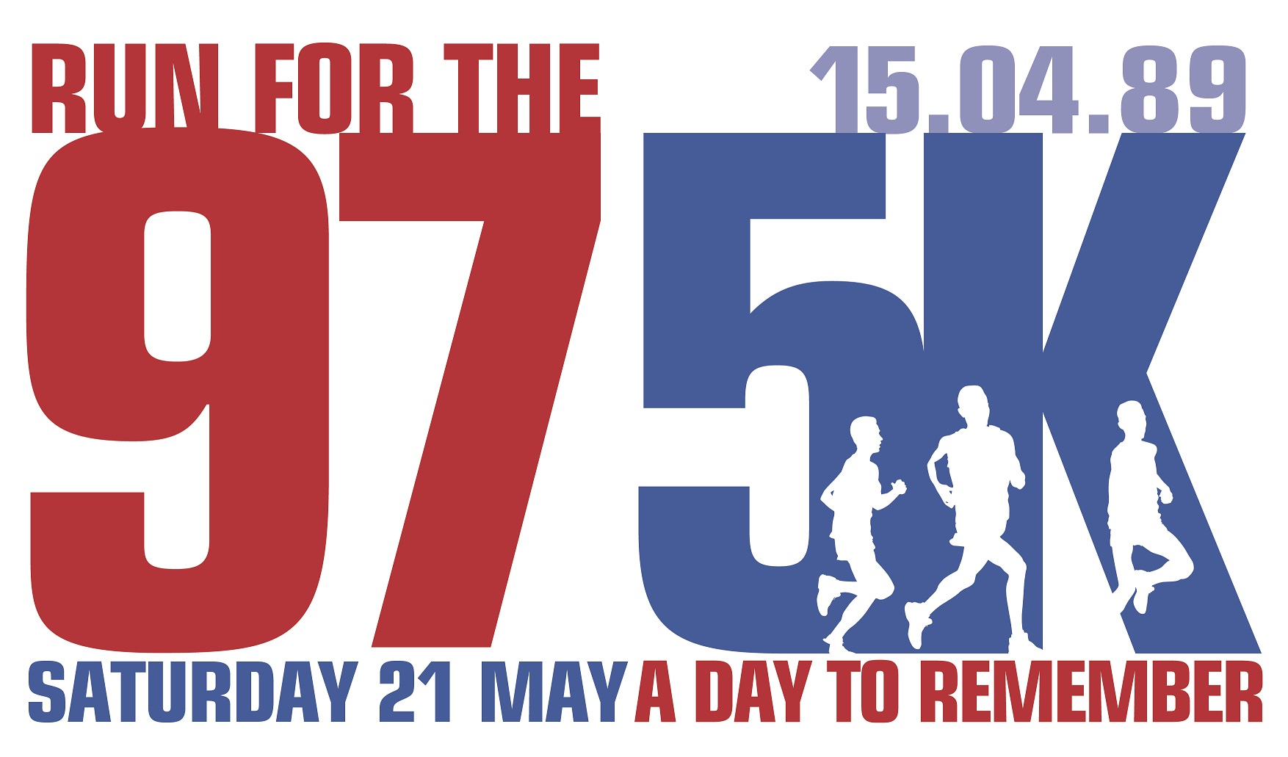
FOR IMMEDIATE RELEASE:
Wednesday 18 May 2022
RUN FOR THE 97 FUN RUN RETURNS THIS WEEKEND TO HONOUR LOST FANS

Community legacy fun run to celebrate lives of
The 97, their families, and the Hillsborough survivors

Charities are Jamie Carragher’s 23 Foundation, LFC Foundation, Everton in the Community, and Stanley Park junior parkrun

Run For The 97 returns to Stanley Park this Saturday (21 May) after a break of three years due to the pandemic. The 5K fun run starts at 9.30am.

First staged in 2015, the community legacy event was created to celebrate and honour the lives of the then 96 Liverpool Football Club fans lost in the Hillsborough tragedy. It also remembers the families and survivors, who have since tirelessly fought for justice with the utmost dignity.

Run For The 97 will now also honour Liverpool FC fan Andrew Devine, who sadly passed away in July 2021. Andrew received life-changing injuries at Hillsborough, he died 32 years after the disaster.

To date, Run For The 97 has helped to raise more than £35,000 for good causes in the city.

Official charities for 2022 are Jamie Carragher’s 23 Foundation, LFC Foundation, and Everton in the Community. A new charity addition for 2022 is Stanley Park junior parkrun.

The eighth annual Run For The 97 takes place in Stanley Park – the perfect setting being located between Liverpool Football Club’s Anfield Stadium and Everton Football Club’s Goodison Park.

Stage activity with special guests starts at 9am. The 5K starts at 9.30am, followed by the 1 Mile at 10.30am for youngsters aged 12 and under. The event is open to everyone as they walk, jog or run to remember The 97.

Reds and Blues will stand by side as football club anthems, Liverpool FC’s You’ll Never Walk Alone and Everton FC’s Z Cars are played, followed by a minute’s applause to remember The 97.

The 5K participants will cross the start line at 9.30am to the sound of The Justice Collective’s cover of The Hollies’ classic He Ain’t Heavy, He’s My Brother – the song which unites Liverpool and Everton and shows the solidarity of the Red and Blue sides of the city.

All 5K participants will receive a specially designed yellow T-shirt to wear during the run to demonstrate a display of unity and remembrance. They will be presented with a commemorative medal when they complete their run.

Those taking part in the 1 Mile distance are invited to wear football shirts to proudly display their club colours. They will receive a medal. They will set off to the sounds of The Farm’s Altogether Now.

Overseas virtual runners will be sent their run number and medal when signing up.

The LFC Foundation will host free family sport and play activities from its Go Play! programme, with giveaways from Everton in the Community.

A regular on match days at Anfield and Goodison, Fans Supporting Food Banks will have a drop-off point on the race showground for donations of non-perishable items.

Refreshments will be available to purchase from a number of concession stalls, who are kindly supporting the event charities with a donation.

This year’s event was launched recently by guests at Hotel TIA, a Liverpool FC inspired boutique hotel on Anfield Road, a short walk from Liverpool FC’s home ground and located adjacent to Stanley Park.

Guests attending on event day include former Liverpool Football Club players Jamie Carragher, David Fairclough, Alan Kennedy and Sammy Lee; Hillsborough family members Margaret Aspinall, Sue Roberts and Steve Kelly; Liverpool City Region Metro Mayor Steve Rotheram; and mammoth charity fundraiser Everton fan Speedomick.

The line-up also features stadium announcers from both sides of Stanley Park. Graeme White from Everton FC’s Goodison Park will host the stage activity. Liverpool FC’s Voice Of Anfield George Sephton has supported the event from the very beginning.

So far more than 1,000 people have signed up to either take part on the day in Stanley Park, or run virtually across the UK or internationally.

Overseas participants taking part on the day in Stanley Park are travelling from Australia, Cyprus, Denmark, Germany, Northern Ireland, Poland, Thailand, and the USA.

The event last took place in Stanley Park in 2019 due to the global pandemic. For the past two years, it has been held as a virtual run enabling people to still support the cause wherever they are based in the world.

In recent years, overseas football fans have supported the event – and they continue to do so. International virtual runners are taking part in Austria, Canada, Denmark, Finland, Germany, Hong Kong, Ireland, Jersey, Netherlands, Northern Ireland, Norway, Singapore, South Africa, Switzerland, and 58 entries from across America.

Margaret Aspinall, former Chair of the now disbanded Hillsborough Family Support Group (HFSG), lost her 18-year-old son James at Hillsborough. Margaret continues to support Run For The 97 and will be present on the day, as she has done since the event was first launched.

Margaret Aspinall commented: “To see everyone come together again, united, it will show people all over the country what we are as a city. People running in memory of The 97, enjoying themselves but also doing some good for the communities of this city – it’s brilliant.”

Sue Roberts, former HFSG Secretary, lost her 24-year-old brother Graham at Hillsborough. Sue will run on Saturday and has taken part every year, including the two virtual runs in 2020 and 2021.

Family member Steve Kelly lost his brother Michael, aged 38. Steve has been involved with RFT97 since the start and has taken part every year since 2015.

Margaret, Sue and Steve continue to be active in the ongoing campaign for a Hillsborough Law.

Official charities – Jamie Carragher’s 23 Foundation, LFC Foundation, Everton in the Community, Stanley Park junior parkrun – all support the vision of creating a legacy to honour The 97 while ensuring local communities benefit through their work.

Jamie Carragher from the 23 Foundation explained: “There is great solidarity between the two clubs and the city – and Run For The 97 even takes place in Stanley Park, between Anfield and Goodison. This tragedy affected everyone, and Everton FC and fans have always shown great support. As a city, we’ll always come together for each other and hopefully we’ll raise lots of funds. The 97 will never be forgotten.”

Participants are encouraged to fundraise or make a one-off donation, and all monies raised will be split equally between the four charities to support vital community outreach programmes.

The official online donation page is https://justgiving.com/campaign/runforthe97 - so far this year’s event has raised £2,000.

Everyone who has registered to take part in Run For The 97 or has made a donation to the RFT97 charity fund via the official Just Giving page will be entered into a draw to win football prizes.

Donated items include signed football shirts from Liverpool FC legend Jamie Carragher, Everton FC Manager Frank Lampard, Everton FC Assistant Manager Duncan Ferguson, and first team Everton FC forward Anthony Gordon, as well as stadium tours at Anfield and Goodison. Full details on the BTR social media channels and website.

On the day Fans Supporting Foodbanks will collect non-perishable food bank donations.

Items urgently needed include UHT milk or powdered milk, fruit cordial, cereal, pasta/curry sauces, tinned sponge pudding, tinned tomatoes and carrots, tinned spaghetti, tinned carrots, noodles and cup-a-soup, tinned rice pudding, instant coffee, instant mash potato, rice, tinned meat and fish, tinned fruit, jam, biscuits, and snack bars.

BTR Liverpool organise and deliver Run For The 97. BTR Liverpool is the leading independent organisation for creating, managing and delivering headline running events across Liverpool City Region. Its extensive portfolio covers various distances across different terrains, all with an ongoing commitment to sustainability.

The RFT97 entry fee pays to stage and deliver all aspects of the event including run numbers, T-shirts and medals, and event day facilities.

Online entries will close at midnight on Thursday 19 May. Enter online at https://www.btrliverpool.com/97-5k-event

Website www.btrliverpool.com
Facebook Facebook/BTR Liverpool
Twitter @BTRLiverpool
Instagram @btrliverpool
Hashtag #BTRRaces
#LetsGetBackOutThere
#RunToRememberThe97

ENDS

Notes to Editors

OFFICIAL LAUNCH IMAGES:
Images by Paul Francis Cooper/BTR Liverpool

OFFICIAL LAUNCH VIDEO:
A new video promoting this year’s Run For The 97 featuring guest interviews is available for media use by visiting https://www.youtube.com/watch?v=yQ1LPLsUjSQ

CHARITY PARTNERS SOCIAL LINKS:
23 Foundation: @JC23Foundation
LFC Foundation: @LFCFoundation
Everton in the Community: @EITC
Stanley Park junior parkrun: @StanleyParkjpr

About Jamie Carragher’s 23 Foundation:
Jamie Carragher started the 23 Foundation in 2009, naming the charity after the squad number he made famous while playing for The Reds until he retired in 2013. He made 737 appearances and scored five goals for Liverpool FC, and was capped for England 38 times.
The 23 Foundation raises money through the sale of memorabilia, fundraising events and donations, and now has now developed into an organisation that supports charities, clubs, and young people across the world. The capital investment will never be spent, allowing the interest generated and monies raised to benefit young people for many years to come.
In 2020, the charity helped more than 1,000 families, and supported foodbanks, hospitals and NHS staff as part of the Covid-19 community support response. The 23 Foundation celebrated its 10-year anniversary in 2019 and raised £200,000 in aid of Grassroots Football on Merseyside.
www.jamiecarragher23.co.uk

About the LFC Foundation:
The LFC Foundation is the official charity of Liverpool Football Club; delivering a range of programmes and partnerships to create life changing opportunities for children and young people in the Liverpool City Region and beyond.
The charity focuses its work in three key impact areas; wellbeing, skills and communities, and delivers a variety of regular physical activity initiatives in Merseyside including ‘Go Play’, a free multi-sport session delivered in 15 local parks. It also works with the Premier League to implement programmes including Premier League’s Kicks programmes and Primary Stars.
https://foundation.liverpoolfc.com

About Everton in the Community:
Everton in the Community is one of the UK’s top sporting charities, and is considered one of the Premier League’s leading community schemes due to the quality and reach of its programmes. Established in 1988, Everton in the Community has been at the forefront of social intervention across Merseyside, not afraid to tackle issues which others shied away from.
Everton Football Club resides in the Kirkdale ward of Liverpool, which is in the most deprived 5% of neighbourhoods nationally. More than half of the children in the area live in poverty while the area in general faces challenges such as high unemployment, crime and health, housing and education problems.
Everton in the Community delivers more than 40 programmes a year, specifically designed and developed to combat these challenges which are prevalent across Merseyside. Its social programmes tackle issues such as mental health, employability, dementia, education, disability, poverty, and homelessness.
https://www.evertoninthecommunity.org/

About Stanley Park junior parkrun:
Stanley Park junior parkrun is a weekly free 2K timed run at 9am every Sunday for children aged four to 14. The event is run entirely by volunteers. The junior parkrun initiative is part of the wider parkrun programme – and is a great fit promoting health, wellbeing and sport to young people.

About BTR Liverpool:
BTR Liverpool is the leading independent organisation for creating, managing and delivering headline running events in Liverpool City Region. The team stage a number of headline events annually, which continue to develop and grow year on year.
Established in 2006, BTR Liverpool prides itself on the quality and delivery of its events; its strong links with the running community; and engagement with local charities. Its event portfolio includes the Liverpool Skyline Half Marathon; Liverpool Santa Dash; Mersey Tunnel 10K; Port Sunlight 10K and 5K; 52-mile Tour Of Merseyside; Run For The 97 5K; and If You Know Your History 5K.
BTR Liverpool Race Director Alan Rothwell has been part of the running community since he began racing as a teenager, which developed into race organising over 20 years ago. Alan’s own personal achievements include finishing 42 Marathons in a 25-year period – including running the London Marathon 22 times; the New York Marathon six times; as well as the Liverpool and Stockholm Marathons.

About Hotel TIA:
Hotel TIA is a welcoming boutique LFC hotel in Anfield Road, just two-minute walk from Anfield Stadium. It offers beautiful, high standard rooms. Facilities include The Managers’ Lounge for drinks, and The Players’ Lounge for drinks, food, and events. The outside spacious terrace offers views over Stanley Park. All are located on the ground-floor – through the iconic red front door. The hotel offers pre-match meals with Reds’ Legends before LFC home matches, as well as hosting private events. The team host a weekly, free podcast called LFC Talk, recorded at Hotel TIA featuring various guests, including regular voice David Fairclough.
https://www.hoteltia.co.uk

BTR RUNNING EVENTS 2022:
- Sat 21 May: Run For The 97 5K / 1 Mile Fun Run
- Sun 12 June: Port Sunlight Road Race
(10K / 5K / 1K Fun Run)
- Sun 26 June – Sat 2 July: BTR Tour Of Merseyside (52 miles)
- Wed 13 July: Medal Muddle 5K
- Sun 11 September: BTR Mersey Tunnel 10K
- Sun 9 October: If You Know Your History 5K
- Sun 16 October: BTR Wirral 10K
- Sun 4 December: BTR Liverpool Santa Dash
(5K / 1K Mini Dash)
- Sun 12 December: Grinch 5K

BTR RUNNING EVENTS 2023:

- Sat 26 March: BTR Liverpool Skyline Half Marathon

BTR Media Contact:

Erica Dillon
Press Officer, BTR Liverpool
Mobile: 07990 501558
Email: erica@btrliverpool.com
Website: www.btrliverpool.com

