FOR IMMEDIATE RELEASE:
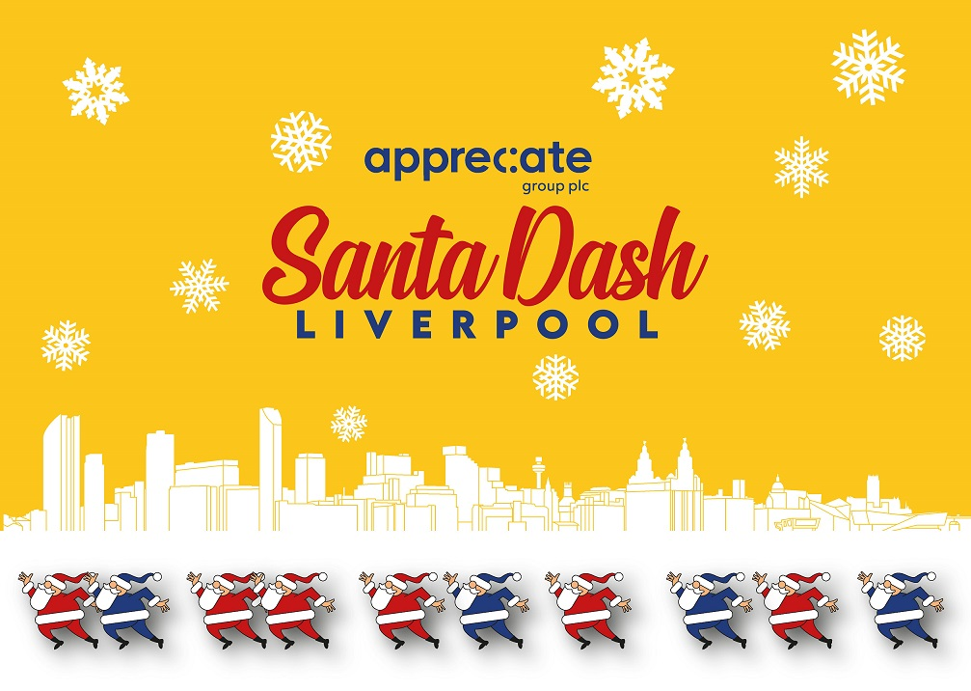
Friday 19 November 2021
FREE BUS TRAVEL FOR ALL SANTAS – AND MEDIA PARTNER IS ANNOUNCED

Arriva North West is welcoming Santas throughout the day

In Demand Radio excited to be on-board for the first time

Excitement is steadily mounting with just two weeks until the return of the Liverpool Santa Dash.

Thought to be the UK’s biggest festive 5K fun run, the Appreciate Group Liverpool Santa Dash is on Sunday 5 December.

Santas will set off at 9.30am from Pier Head Liverpool on the city’s iconic waterfront, before heading through Grade I Listed Royal Albert Dock Liverpool and the city centre, with a spectacular grandstand finish outside Liverpool Town Hall featuring stilt walking festive characters and ‘real’ snow.

Arriva North West is supporting the Liverpool Santa Dash for the fourth time by offering participants free travel on the Arriva bus network across Merseyside throughout Santa Dash day (Sunday 5 December).

To claim complimentary bus travel to or from the city centre, Santas must be wearing their Santa suit and race number on the morning, or their Santa suit and finishers’ medal when travelling home afterwards. There is no time cut off time post run.

Lisa Pearson, Arriva Head Of Marketing, commented: “The Santa Dash is a great event that really unites the people of Liverpool for a day of festive fun while raising much-needed funds for charity. It’s a pleasure to once again be involved by offering free travel to all those taking part. We’re looking forward to seeing lots of red and blue Santas on-board our buses and throughout the city on the day.”

The festive spectacular returns for its 18th consecutive event, and more than 3,000 Santas have already signed up.

Liverpool-based Appreciate Group is this year’s headline partner; event charity is Alder Hey Children’s Charity; with St Johns Shopping Centre hosting the pop-up Santa Dash shop.

Now organisers BTR Liverpool are excited to announce In Demand Radio as official media partner. In Demand Radio launched on DAB in November 2020 for Liverpool and the North West, with award-winning DJ Lee Butler presenting the primetime Brekky Butler weekday breakfast programme and weekend dance show Plastic Surgery.

In Demand anchor Lee Butler, who will also be taking part in this year’s Santa Dash, explained: “We’re proud and thrilled to be official media partner of the Appreciate Group Liverpool Santa Dash. It’s an incredible day with such a great sense of community, love and passion for the event, with participants supporting so many fantastic charities including Alder Hey.

“I can’t wait to be there. We’ll be doing a Ravin’ Fit style warm-up, some of my fellow presenters will be there with our brand new Boogie Bus, and I’ll be joining in alongside the thousands of red and blue Santas. People getting fit while embracing the festive spirit – it’s going to be a very special day.”

BTR Liverpool is the leading independent organisation for creating, managing and delivering headline race events across Liverpool City Region.

Created by BTR Race Director Alan Rothwell, the Liverpool Santa Dash was first staged in 2004. The 1K Mini Dash for under 12s was added in 2007, and blue Santa suits were introduced in 2010.

Liverpool Santa Dash is an accessible event open to everyone – wheelchair participants, walkers, joggers, runners, families, friends, colleagues, tiny Santas in prams, and even four-legged furry Santas.

The pop-up shop at St Johns Shopping Centre is open seven days a week for registration or Santa suit collection. The shop is located on the upper level near the Matalan bridge and will remain open until Saturday 4 December – open Monday to Saturday 9.30am to 5pm, and Sunday 11am to 4pm.

The registration fee covers all costs to organise and deliver the event including road closures, safety measures, Santa suits, medals, goody bags, and entertainment.

Appreciate Group have been based in the region for more than 50 years and are home to many of the nation’s most loved gifting and reward products including Love2shop, highstreetvouchers.com, and Park Christmas Savings.

Dashing Santas are being encouraged to walk, jog or run to raise funds for Alder Hey Children’s Charity. The charity recently launched its new £2.5million Surgical Neonatal Appeal to help develop a state-of-the-art unit for newborn babies and their families.

Any Covid-19 guidelines required at the time of the event will be followed.

For full details and online entry visit https://www.btrliverpool.com/santa-dash

Website www.btrliverpool.com
Facebook Facebook/BTR Liverpool
Facebook/BTRLiverpoolSantaDash
Twitter @BTRLiverpool
Hashtag #LiverpoolSantaDash
#SantaDashDay

ENDS

Notes to Editors

OFFICIAL EVENT IMAGES:
Images by Paul Francis Cooper/BTR Liverpool

OFFICIAL EVENT VIDEO:
A 10-minute video showcasing the last public BTR Liverpool Santa Dash from December 2019 is available for media use by visiting https://youtu.be/qx4_wdnamSo

About Appreciate Group Plc:
Appreciate Group is a leading gifting, prepayment and engagement company, who are experts at creating joyful experiences and connecting people to the things in life they enjoy the most. Their purpose is to create more joy in the world by being trusted to help our customers with celebrating and rewarding.
Appreciate Group is a financial services business providing individuals and businesses with solutions for the moments that matter to them. Everything Appreciate Group does is focused on creating more joy in the world, and the company is trusted to help its customers create moments they can treasure whether they are giving, receiving or experiencing something special.
Appreciate Group has a wide portfolio of brands, designed for the consumer and business customers. Its consumer-facing brands meet a range of prepayment and gifting needs, while its business products help corporate customers reward and recognise their employees and clients.
Appreciate Group is home to many of the country’s most-loved gifting and reward products. Whether it’s saving towards the perfect family Christmas or celebrating with gift cards and vouchers, they create and supply products that millions of people trust when it comes to giving and receiving with family, friends or colleagues.
For further information on Appreciate Group visit https://www.appreciategroup.co.uk/
- Twitter: @AppreciatePlc
- Facebook: Appreciate Group
- Instagram: AppreciateGroup
- LinkedIn: AppreciateGroup

About Alder Hey Children’s Charity:
In September 2021, Alder Hey Children’s Charity launched its new £2.5million appeal to develop a state-of-the-art unit for newborn babies and their families.
The new Surgical NICU unit will address a shared concern between Liverpool Women’s and Alder Hey that babies who need specialist surgery currently have to be transferred to Alder Hey to get the specialist surgical care they need, and are then transferred back to Liverpool Women’s Hospital to continue their specialist neonatal care.
The planned facility will cost £16.5million to build, with the Charity Appeal aiming to contribute £2.5million to provide ‘over and above’ enhancements and equipment for both the clinical space and family areas. This will help elevate it from a facility that provides families with a safe and secure environment for them and their newborns, to a truly world-class facility that wraps around families with the most vulnerable babies in the region.

About St Johns Shopping Centre:
St Johns Shopping Centre is the largest indoor shopping centre in Liverpool and a leading centre in the North West region. Located in the heart of the city since 1969, St Johns is home to over 100 businesses, from local retailers to national brands, and is a hub for fashion, homeware, jewellery, fragrances and more. Retailers include JD Sports, Matalan, HMV, F.Hinds and the official LFC Store.

About Arriva North West:
Arriva is one of the leading providers of passenger transport in Europe, employing over 46,000 people and delivering 1.2 billion passenger journeys a year, prior to the Covid-19 pandemic, across 14 European countries. We are owned by Deutsche Bahn (DB).
We operate nearly 5,000 buses across the UK, in London, the South East, the Midlands, Yorkshire, the North East, the North West and North Wales, employing over 15,000 people. Arriva UK Bus also operates the innovative Demand Responsive Transport (DRT) ArrivaClick operations in Watford and Leicestershire.
We are also a major train operator in the UK, utilising rural commuter lines through to long distance and inter-urban services. Arriva’s UK rail companies include CrossCountry, Chiltern, Arriva Rail London (“the Overground”) and open access operator Grand Central. Arriva also provides rail maintenance services via our Arriva TrainCare business.

About In Demand Radio:
In Demand Radio launched on DAB in November 2020 for Liverpool and the North West. At In Demand, Lee Butler takes prime position, hosting the ‘Brekky Butler’ weekday breakfast show, as well as Plastic Surgery. The award-winning DJ also joins the likes of Tiesto, Dave Pearce, Judge Jules and Roger Sanchez who all have weekly shows on the station.
Visit www.indemandradio.com for more information.

About BTR Liverpool:
BTR Liverpool is the leading independent organisation for creating, managing and delivering headline race events in Liverpool City Region. The team stage a number of headline events annually, which continue to develop and grow year on year.
Established in 2006, BTR Liverpool prides itself on the quality and delivery of its events; its strong links with the running community; and engagement with local charities. Its event portfolio includes the Liverpool Skyline Half Marathon; Liverpool Santa Dash; Mersey Tunnel 10K; Wirral 10-Mile and 10K; Port Sunlight 10K and 5K; 52-mile Tour Of Merseyside; Run For The 96 5K; and If You Know Your History 5K.
BTR Liverpool Race Director Alan Rothwell has been part of the running community since he began racing as a teenager, which developed into race organising over 20 years ago. Alan’s own personal achievements include finishing 42 Marathons in a 25-year period – including running the London Marathon 22 times; the New York Marathon six times; as well as the Liverpool and Stockholm Marathons.

BTR RUNNING EVENTS 2021:
- Sun 5 December: Appreciate Group
Liverpool Santa Dash
(5K / 1K Mini Dash)
- Sun 12 December: Grinch 5K
BTR RUNNING EVENTS 2022:
- Sun 27 March: BTR Liverpool Skyline Half Marathon
BTR Liverpool 10 Mile Road Race
- Sat 21 May (TBC): Run For The 96 5K / 1 Mile Fun Run
- Sun 12 June (TBC): Port Sunlight Road Race
(10K / 5K / 1K Fun Run)
- Sun 26 June – Sat 2 July: BTR Tour Of Merseyside (52 miles)
- Sun 11 September: BTR Mersey Tunnel 10K
- Sun 30 October: BTR Wirral 10 Mile Road Race
BTR Wirral 10K Road Race

BTR Media Contact:

Erica Dillon
Press Officer, BTR Liverpool
Mobile: 07990 501558
Email: erica@btrliverpool.com
Website: www.btrliverpool.com

