FOR IMMEDIATE RELEASE:
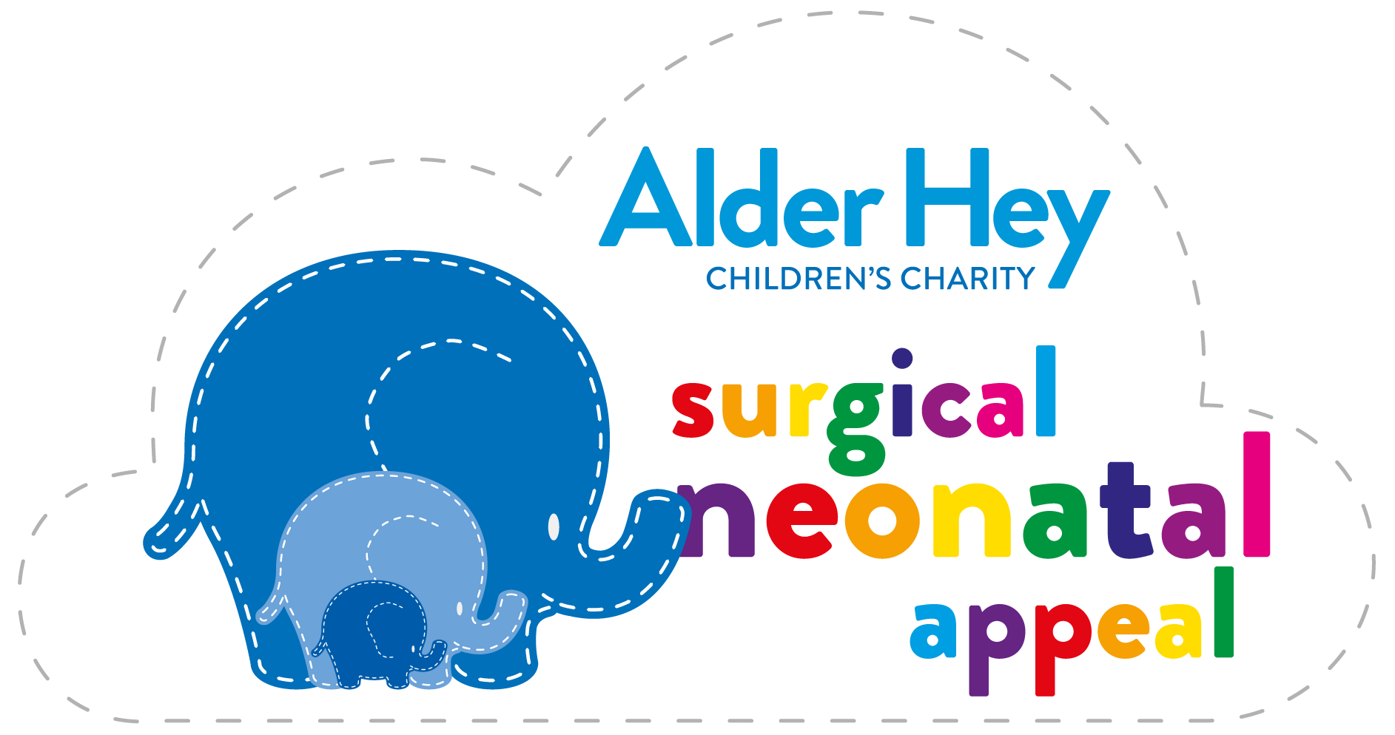
Tuesday 26 October 2021
LIVERPOOL SANTA DASH ANNOUNCE ALDER HEY
AS CHARITY PARTNER

Santas invited to fundraise for new neonatal campaign

Four-year-old ambassador Betty will officially
start the annual festive fun run

Alder Hey Children’s Charity has been revealed as the official charity partner for the Liverpool Santa Dash 2021.

Santas will be delighted the event returns in real-life on Sunday 5 December after the fun run was staged virtually last year due to Covid-19 guidelines. The event starts at 9.30am from Pier Head Liverpool.

Organisers BTR Liverpool are delighted to welcome Alder Hey Children’s Charity on-board as part of the event. The hospital recently launched its new £2.5million Surgical Neonatal Appeal to help develop a state-of-the-art unit for newborn babies and their families.

Dashing Santas are being encouraged to walk, jog or run to raise funds for Alder Hey Children’s Charity.

Highly regarded as the city’s kick-start to Christmas, the event returns for its 18th consecutive year and is thought to be the UK’s biggest festive 5K fun run.

The news follows the recent announcement of new headline partner, Liverpool-based gifting company Appreciate Group. The partnership also gives this year’s event a new title – it will be known as the Appreciate Group Liverpool Santa Dash.

Alder Hey’s new fundraising campaign was launched in September by Liverpool Football Club legend Jamie Carragher, who spent the first six weeks of his own life in Alder Hey’s neonatal ward.

The new Surgical NICU is a joint project between Alder Hey and Liverpool Women’s NHS Foundation Trust as the Liverpool Neonatal Partnership. It will offer a further 22 neonatal cots for Liverpool, including 18 individual family rooms where parents can remain alongside their poorly newborns receiving expert care.

One very special mini Santa set to attend the event is four-year-old Betty from Warrington with Mum Karen, Dad Phil, brother Stanley, and sister Martha. Betty is also one of the children featured in the Christmas pyjama campaign with retailer Matalan.

Betty was born four months premature weighing only 650 grams. She needed neonatal intensive care at Liverpool Women’s Hospital, where her immature lungs were supported by a ventilator. Her bowel was perforated in two places and she was taken to Alder Hey by ambulance for emergency surgery, the first of many visits which would follow. Baby Betty was to endure infections, blood transfusions, blood cultures, lumbar punctures, bowel procedures, and an emergency tracheostomy – but the youngster continued to fight on.

Helped and supported by the dedicated team of professionals at Alder Hey, Karen and Phil trained to have the knowledge and skills to deal with Betty’s ongoing medical needs so the family could be reunited. And after 13 months, Betty finally made it home. Betty is still receiving care from Alder Hey.

Adam Dixon, Community Fundraiser for Alder Hey Children’s Charity, commented: “We are incredibly excited to be the official charity of the Appreciate Group Liverpool Santa Dash 2021 – a massive thank to our friends at BTR Liverpool who have supported Alder Hey Children’s Charity for a number of years. We know our amazing Santas will raise a huge amount for our brand new Surgical Neonatal Appeal to help the region’s babies and their families – just like Betty. See you all at the start line, Ho Ho Ho!”

Betty’s Dad Phil added: “Betty is just amazing. She is the most delightful, placid, and brave little girl. Betty’s journey will continue and the remarkable NHS that saved her countless times will continue on this road with her. Betty is our little miracle and no matter what comes we will all continue to love her with everything we have, and with utter joy and immense gratitude to those that never gave up on her – and gave us this most precious gift.”

Created by BTR Race Director Alan Rothwell, the Liverpool Santa Dash was first staged in 2004. A separate 1K Mini Dash for under 12s was added in 2007, and blue Santa suits were introduced three years later.

Plans are well underway to bring the Liverpool Santa Dash to life once again as a public event after being staged virtually last year. Organisers are pulling out all the stops to enable participants get their Santa Dash fix in real-life. Any Covid-19 guidelines required at the time of the event will be followed.

BTR Liverpool is the leading independent organisation for creating, managing and delivering headline race events across Liverpool City Region. Its extensive portfolio also includes the BTR Liverpool Skyline Half Marathon; BTR Mersey Tunnel 10K; BTR Port Sunlight 5K and 10K; and 52-mile BTR Tour Of Merseyside.

BTR Race Director Alan Rothwell said: “The Appreciate Group Liverpool Santa Dash is family friendly, special, full of energy and laughter – so we’re thrilled that Alder Hey Children’s Charity has joined the Liverpool Santa Dash family for what promises to be a very special year. And we’re thrilled that Betty and her family will be joining us on the day to help start the Santa Dash. Christmas is all about youngsters so this is the ideal opportunity to sign up, pull on your Santa suit, and dash round the city to raise funds for Alder Hey. Help make a real difference to support children and their families in their time of real need.”

The 5K route includes city centre landmarks Museum Of Liverpool, Grade I Listed Royal Albert Dock Liverpool, and a grandstand finish outside Liverpool Town Hall featuring stilt walking festive characters and ‘real’ snow.

Liverpool Santa Dash is an accessible event open to everyone, from those running purely for fun with others fundraising. Each year Santas include wheelchair participants, walkers, joggers, runners, families, friends, colleagues – even tiny Santas in prams and four-legged furry Santas.

The event acts as a platform for community groups, businesses, and charities to fundraise independently while taking part.

The registration fee covers all costs to organise and deliver the event including road closures, safety measures, Santa suits, medals, goody bags, and entertainment.

Liverpool-based Appreciate Group is the headline partner for the Liverpool Santa Dash 2021.

Appreciate Group is home to many of the nation’s most loved gifting and reward products including Love2shop, highstreetvouchers.com, and Park Christmas Savings. Based in the region for more than 50 years, Appreciate Group are committed to supporting their community.

Online registration is open. A pop-up shop for in-person registration and Santa suit collection will open on Monday 1 November at St Johns Shopping Centre. The shop will be open daily until Saturday 4 December 2021.

For full details visit https://www.btrliverpool.com/santa-dash

Website www.btrliverpool.com
Facebook Facebook/BTR Liverpool
Facebook/BTRLiverpoolSantaDash
Twitter @BTRLiverpool
Hashtag #LiverpoolSantaDash
#SantaDashDay

ENDS

Notes to Editors

OFFICIAL EVENT IMAGES:
Images by Paul Francis Cooper/BTR Liverpool

OFFICIAL EVENT VIDEO:
A 10-minute video showcasing the last public BTR Liverpool Santa Dash from December 2019 is available for media use by visiting https://youtu.be/qx4_wdnamSo

About Appreciate Group Plc:
Appreciate Group is a leading gifting, prepayment and engagement company, who are experts at creating joyful experiences and connecting people to the things in life they enjoy the most. Their purpose is to create more joy in the world by being trusted to help our customers with celebrating and rewarding.
Appreciate Group is a financial services business providing individuals and businesses with solutions for the moments that matter to them. Everything Appreciate Group does is focused on creating more joy in the world, and the company is trusted to help its customers create moments they can treasure whether they are giving, receiving or experiencing something special.
Appreciate Group has a wide portfolio of brands, designed for the consumer and business customers. Its consumer-facing brands meet a range of prepayment and gifting needs, while its business products help corporate customers reward and recognise their employees and clients.
Appreciate Group is home to many of the country’s most-loved gifting and reward products. Whether it’s saving towards the perfect family Christmas or celebrating with gift cards and vouchers, they create and supply products that millions of people trust when it comes to giving and receiving with family, friends or colleagues.
For further information on Appreciate Group visit https://www.appreciategroup.co.uk/
- Twitter: @AppreciatePlc
- Facebook: Appreciate Group
- Instagram: AppreciateGroup
- LinkedIn: AppreciateGroup

About Alder Hey Children’s Charity:
In September 2021, Alder Hey Children’s Charity launched its new £2.5million appeal to develop a state-of-the-art unit for newborn babies and their families.
The new Surgical NICU unit will address a shared concern between Liverpool Women’s and Alder Hey that babies who need specialist surgery currently have to be transferred to Alder Hey to get the specialist surgical care they need, and are then transferred back to Liverpool Women’s Hospital to continue their specialist neonatal care.
The planned facility will cost £16.5million to build, with the Charity Appeal aiming to contribute £2.5million to provide ‘over and above’ enhancements and equipment for both the clinical space and family areas. This will help elevate it from a facility that provides families with a safe and secure environment for them and their newborns, to a truly world-class facility that wraps around families with the most vulnerable babies in the region.

About BTR Liverpool:
BTR Liverpool is the leading independent organisation for creating, managing and delivering headline race events in Liverpool City Region. The team stage a number of headline events annually, which continue to develop and grow year on year.
Established in 2006, BTR Liverpool prides itself on the quality and delivery of its events; its strong links with the running community; and engagement with local charities. Its event portfolio includes the Liverpool Skyline Half Marathon; Liverpool Santa Dash; Mersey Tunnel 10K; Wirral 10-Mile and 10K; Port Sunlight 10K and 5K; 52-mile Tour Of Merseyside; Run For The 96 5K; and If You Know Your History 5K.
BTR Liverpool Race Director Alan Rothwell has been part of the running community since he began racing as a teenager, which developed into race organising over 20 years ago. Alan’s own personal achievements include finishing 42 Marathons in a 25-year period – including running the London Marathon 22 times; the New York Marathon six times; as well as the Liverpool and Stockholm Marathons.

BTR RUNNING EVENTS 2021:
- Sun 31 October: BTR Wirral 10 Mile Road Race
BTR Wirral 10K Road Race
- Sun 5 December: Appreciate Group
Liverpool Santa Dash
(5K / 1K Mini Dash)

BTR RUNNING EVENTS 2022:
- Sun 27 March: BTR Liverpool Skyline Half Marathon
BTR Liverpool 10 Mile Road Race
- Sat 21 May (TBC): Run For The 96 5K / 1 Mile Fun Run
- Sun 12 June (TBC): Port Sunlight Road Race
(10K / 5K / 1K Fun Run)
- Sun 26 June – Sat 2 July: BTR Tour Of Merseyside (52 miles)
- Sun 11 September: BTR Mersey Tunnel 10K

BTR Media Contact:

Erica Dillon
Press Officer, BTR Liverpool
Mobile: 07990 501558
Email: erica@btrliverpool.com
Website: www.btrliverpool.com

